AGENDA - Little Hoole Parish Council  Members of the Council are summoned to the Parish Council Meeting to be held on  Mon 12th Jan 2026 at 7pm  The Residents’ Lounge, Old Mill Court, Liverpool Old Road, Walmer Bridge, PR4 5QU  Paul Cafferkey, Clerk & Responsible Financial Officer | 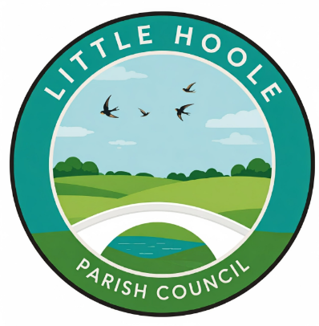
- Apologies for absence
- To approve the recommendation of the interview panel to appoint (co-opt) Emma Moore to the vacant post of Parish Councillor.
- To agree the Minutes of the last Parish Council Meeting held on the 8th Dec 2025.
- To receive declarations of interest.
- Matters arising from the minutes of last meeting
  - Public Time: to invite and listen to issues raised by members of the public.
  - To consider the following Planning Applications:
    - 07/2025/00965/PIP. The Willows Brook Lane PR4 5JB. Permission in principle for the erection of up to 1no. dwelling
    - 07/2025/00962/HOH. 20 Hall Carr Lane PR4 5RA. Side extension with front dormer, single storey rear/side extension with flat roof, dormer to rear elevation, open porch to front elevation and cosmetic amendments.
    - 07/2025/00958/DIS. Bakers Farm Brook Lane PR4 5JB. Discharge of conditions 5 and 6 pursuant to permission 07/2024/00823/OUT for erection of 3 new dwellings.
  - To approve the following transactions in the bank for Dec 2025.

  - Payments approved by email or pre-approved and retrospectively noted: none
  - Payments for approval:
    - Clerk’s claim for Dec 2025 of 14.75 hours.
    - SLCC Annual Subscription for Clerk £116.00.
    - Erection of Christmas Tree by Mayor’s of Eccleston £200.
  - To approve the Finance Statement as 31st Dec 2025.
  - To review and approve the following existing policies and procedures:
    - Code of Conduct
    - HR Disciplinary Policy
    - HR Equality & Diversity Policy
    - HR Grievance Policy
    - HR Homeworking Policy
    - HR Sickness Policy
  - To approve the following replacement policies as recommended by NALC:
    - Standing Orders
    - Financial Regulations
  - To adopt the following new policies:
    - Information Technology
    - Data Protection
    - Use of Artificial Intelligence
  - To review the following areas relating to the Parish Council’s Bank Account:
    - Signatories to the bank account
    - Direct Debits
  - To note the Parish Council’s Accessibility Statement with regard to its website, as run by Easy Web Sites.
  - To review and re-approve the Parish Council’s Risk Management Plan.
  - Update: re the replacement of the two bus shelters at the junction of Liverpool Old Road and Liverpool New Road (Star Garage) at a cost of £15,942.
  - Update re Memory Bench
  - Update re tree carving on Dob Lane Recreation Park.
  - Lancashire County Council’s Public Rights of Way (PRoW) Consultation.
  - Update re PRoW 0707050, corner of A59 and Gill Lane.
  - To review the cost of moving SPiDs and consider alternative contractor.
  - Update re Insurance Claim.
  - Information and Updates.
  - Correspondence – none
  - To agree the date, time, and venue for the Mar 2026 meeting (no meeting in Feb).
Members of the public are welcome to attend meetings to raise any relevant matters. Alternatively, if you cannot attend the meeting but wish to raise a matter or ask a question, this can be done on your behalf by contacting the Parish Clerk (Paul Cafferkey) via email clerk@littlehoole-pc.gov.uk or mobile phone 07966267186.
Visit the Little Hoole Parish Council Website https://www.littlehoole-pc.gov.uk or scan the following QR code.



Prepared and approved by Paul Cafferkey, Clerk – Little Hoole Parish Council,
7th Jan 2026

